**Basic Arithmetic and the Modulo Operator in JavaScript**

**Arithmetic:**

Addition:

Var a = 2+3; //5

Subtraction

Var b = 10-2; //8

Multiplication

Var c = 3*3; //9

Division

Var d = 12/3; //4 6/4 = 1.5

**Modulo**

Var e = 9%6; //3

Var cost = 3+5*2; //13

Var cost = (3+5)*2; //16

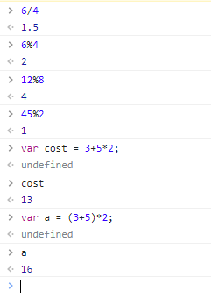

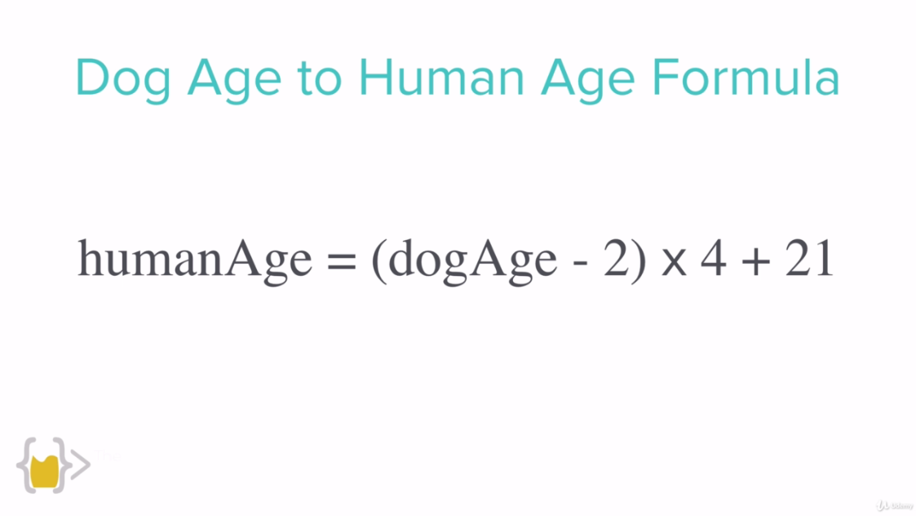

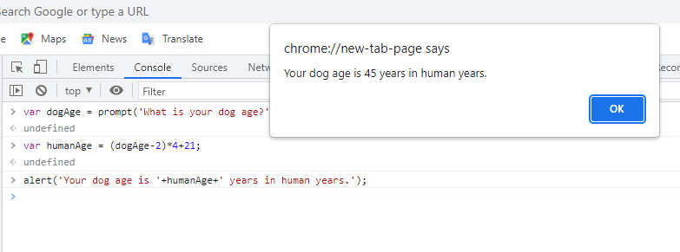

**Increment and Decrement Expressions**

Same as we learnt in C and C++ as well as other programming languages like java.

**Increment:**

X = x+1;

X++;

++X;

Var x = 5;

X= x+1; //6

**Decrement:**

X = x-1;

X--;

--X;

Var x = 5;

X= x-1; //4

//////////////////////////////////////////////////////

Var x = 5;

X = x+2; //7

X+=2; //7

